|  |  |  |  |  |  |  |
| --- | --- | --- | --- | --- | --- | --- |
| DEPARTMENT / UNIT | : | INSTITUTE FOR RESEARCH, DEVELOPMENT AND INNOVATION (IRDI) – RESEARCH ADMINISTRATION | | | | logo |
| **TITLE** | : | MANAGEMENT OF RESEARCH PROJECTS | | | |
| **Document Code** | : | IMU/SOP/IRDI/02 | Edition | : | 18 |
| **Date** | : |  | Pages | : | 12 |

1. **INTRODUCTION**

**1.1 Authority of the IMU Joint Committee on Research and Ethics (IMU-JC)**

1. To evaluate proposals on all types of research, including biomedical and clinical research.
2. To approve, disapprove or modify the proposed studies.
3. To endorse progress reports from the investigators.
4. To suspend or terminate approved studies.
5. To place restrictions on a study.

**1.2 Membership of the IMU-JC**

1. The composition of IMU-JC membership is in compliance with the Malaysian GCP Guidelines, which consists of:
2. At least five members.
3. At least one member whose primary area of interest is in a non-scientific area.
4. At least one member who is independent of the institutional/trial site.
5. Selection of IMU-JC members is based on nomination and endorsement by the committee.
6. The duration of IMU-JC membership is for two years.
7. For renewal of membership, a letter will be sent to the particular member after endorsement by the IMU-JC.
8. For resignation, the member should submit a resignation letter to be endorsed by the IMU-JC.
9. Replacement of any members should be proposed and endorsed by IMU-JC.
10. Membership can be terminated if the member does not attend **five (5) consecutive** meetings in a year without valid reasons.
    * 1. All IMU-JC members, Research Management Centre (RMC) and observers are required to sign a confidentiality agreement.
      2. All IMU-JC members should voluntarily declare their conflict of interest (COI) and shall not participate in deliberations and voting in the event that a COI exists.
      3. All IMU-JC members need to attend initial and continued education regarding the ethics and science of biomedical research.
11. All IMU-JC members need to attend the Good Clinical Practice (GCP) training and refresher course every five (5) years.
12. All IMU-JC members are encouraged to obtain additional continued education as deemed appropriate and where required.
13. IMU will also organize relevant training and provide funding for training of all IMU-JC members as deemed required.
14. Evidence of participation need to be submitted to the Research Management Centre (RMC) within fourteen (14) days after the completion of the training
15. The RMC will keep a record of all the training attended by the IMU-JC members and table it in its annual report.

1.2.4 The Chairperson will abstain from making any decision on issues or matters that will create any conflict of interests with other members or the researcher(s).

1.2.5 IHH Healthcare Berhad is the ultimate shareholder of IMU Education Bhd. IMU-JC is the Research and Ethical Committee of IMU Education Bhd. IMU will appoint an insurance company to provide liability coverage to IMU-JC members.

1.2.6 The establishment of the IMU-JC is approved and endorsed by Senate Members of the International Medical University.

1.2.7 The remit of IMU-JC members is stipulated in the appointment letter.

1.2.8 The quorum for IMU-JC meeting shall be at least five (5) members, and the composition should comply with the Malaysia GCP Guidelines, which consists of

ii) At least one member whose primary area of interest is in a non-scientific area.

iii) At least one member who is independent of the institutional/trial site.

1.2.9 The Research Management Centre (RMC) consists of the following:

1. Director (Institute for Research, Development & Innovation)
2. Deputy Director, Research (Institute for Research, Development & Innovation)
3. Administrative Staff (Institute for Research, Development & Innovation)

1.2.10 The internal procedures will follow closely with the remit of the IMU-JC following the governance structure of the IMU.

**1.3 Review Procedures of the IEC/IRB**

**1.3 (i) Conduct / Frequency of Meeting**

The IMU-JC shall meet once every month. At the discretion of the Chairman, additional meetings may be convened or a scheduled meeting postponed (if there is no issue to be discussed).

IMU-JC meetings shall be conducted in accordance with the “Good Clinical Practice” (GCP), “Good Laboratory Practice” (GLP), WMA Declaration of Helsinki and “International Guiding Principles for Animal Research”.

Calling notice will be sent to all members three (3) weeks before the date of meeting.

Meeting package/documents will be sent out / emailed to the IMU-JC members within Five (5) working days prior to the meeting date.

**1.3 (ii) Review of Protocols / Procedure**

The IMU-JC will evaluate and make appropriate recommendations on all research proposals including all ethical issues guided by the codes of good practice as set in the guidelines for “Good Clinical Practice” (GCP), “Good Laboratory Practice” (GLP) and “International Guiding Principles for Animal Research”.

Decision making process will be by consensus of all the IMU-JC members.

The IMU-JC will review an application on elements such as scientific design and conduct of the study, recruitment of research participants, care and protection of research participants, protection of research participant’s confidentiality, informed consent process and community considerations. The Informed Consent will be reviewed according to the requirement set in the Malaysian Guidelines for GCP. All amendments to the protocol, Informed Consent and other documents related to the research process received should be submitted to the IMU-JC for review and comments. In addition, the insurance coverage for all subjects participated in the study will be reviewed by the IMU-JC members.

IMU-JC members with conflict of interest will not participate in the discussion, review and approval process of any project proposals submitted by the person.

The decision on the proposal could be *‘Recommended with No Amendments Required [Full Approval]’, ‘Recommended with Amendments [Conditional Approval]’ or ‘Not Recommended / Rejected’. For proposals that are given conditional approval,* the Principal Investigator may be requested to amend and revise the proposal, taking into the consideration of the comments of IMU-JC. *For projects that are rejected / not recommended, IMU-JC may recommend the Principal Investigator to revise the proposal and submit it again for presentation at the next IMU-JC meeting if he/she is still interested.*

The decision of the IMU-JC on the proposal will be communicated to the researcher within 14 days from the date of the proposal evaluation. The decision of the IMU-JC is final. No appeal will be allowed for any rejected protocols or proposals.

In the event a follow-up is required on protocol amendments that are likely to affect the rights, safety and wellbeing of subjects; all serious and unexpected adverse events and any event or new information that may affect the benefit-risk ratio of the study, the investigator/sponsor is required to submit all the documents to be reviewed by the IMU-JC. A decision will be made at the IMU-JC meeting and letter will be issued by the RMC to the Principal Investigator/Supervisor involved within fourteen (14) working days.

**1.3(iii) Responsibilities of Applicants on any clinical trials or stem cells research are as follows:**

1. To notify to the IMU-JC on all protocols, recruitment material, Patients/Study Information Sheet, Informed Consent form and participants’ information amendments.
2. To inform of any serious and unexpected adverse event reports be it serious or not.
3. To inform the IMU-JC of any termination of study or study is put on hold.

**2.0 OBJECTIVE**

To ensure that all research projects are managed efficiently so as to ensure the smooth running of the IMU-JC and Research Management Centre (RMC).

**3.0 SCOPE**

This SOP covers the procedures involved from application to the completion of the research project.

**4.0 DEFINITION**

4.1 IRDI Institute for Research, Development and Innovation

4.2 IMU-JC IMU Joint-Committee on Research and Ethics

4.3 IMU-RL IMU Research Laboratory

4.4 RMC Research Management Centre

**5.0 RESPONSIBILITY**

The Deputy Director, Research of IRDI (Research) and the Staff at RMC are responsible for this SOP.

**6.0 PROCEDURE DETAILS**

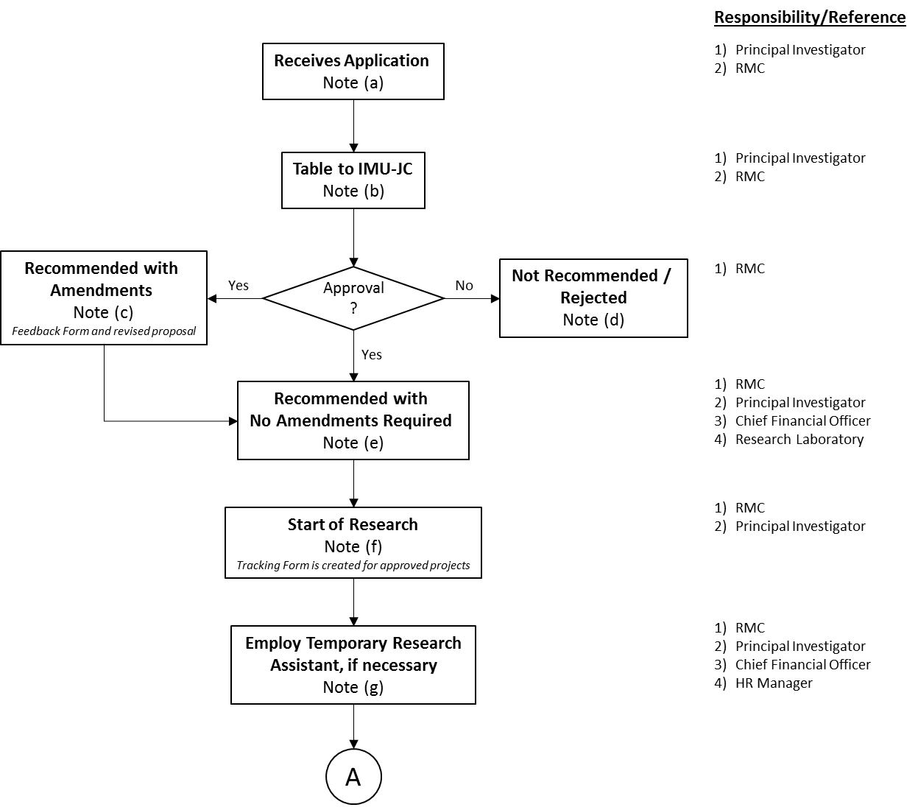

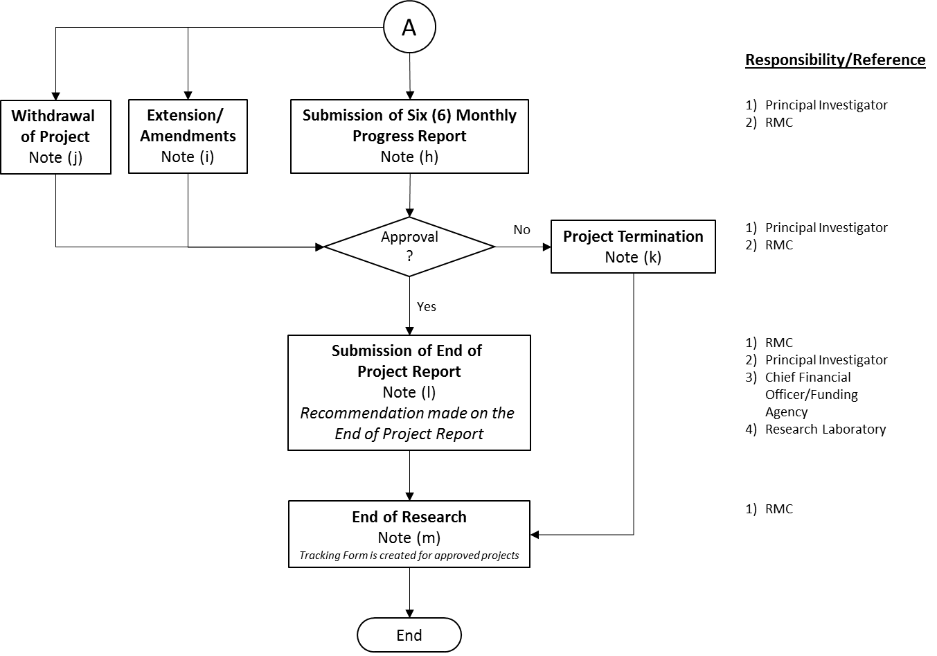

**7.0 NOTES**

|  |  |
| --- | --- |
| Note (a) | There are two types of research projects; therefore, a research proposal must be submitted in the designated proposal form. For an IMU funded project, the Application Form as shown in **Appendix 1** should be used. Where the research proposal is to be submitted to an external funding agency (e.g. MOSTI, Foundations and Private Companies) the appropriate form of the agency should be used for presentation at the IMU Joint-Committee on Research and Ethics (IMU-JC) for approval. Besides filling up the forms from the designated agency, a copy of the IMU Research Application Form has to be filled-up too once the funding agency approved the project and inform us.  However, as and when required, the Principal Investigator has to fill in additional forms shown in **Appendix 1a, 1b, 1c, 1d or 1e** for their research project.  If the investigator needs to submit the research proposal to an external agency for funding consideration urgently before the IMU-JC can meet to consider it, the proposal can be submitted first after discussion with the Chairman of IMU-JC or his representative and a provisional approval can be considered/will be given. The proposal will need to be submitted for consideration and approval by the IMU Joint-Committee on Research and Ethics at the next scheduled meeting.  Research on stem cells / clinical trials should comply with the Ministry of Health (MOH) requirements and guidelines as specified in the Malaysian GCP.  The following documents are required to be submitted for any new submission of research on stem cells/clinical trials:   1. Study Protocol / Amendments 2. Updates of Consent form 3. Recent Investigator’s Brochure 4. Advertisement (if necessary) 5. Insurance Coverage 6. Indemnity Agreement 7. Investigator’s curriculum vitae, qualification (GCP certificate accredited by NCCR) 8. Payment and Compensation 9. Recruitment procedure   All amendments to the protocol, informed consent form and trial related documents need to be submitted to the IMU-JC for review and approval.  Any supplementary information should be submitted to the Research Management Centre (RMC) within fourteen (14) working days after the issuance of the decision letter by the RMC.  **Institutional Biosafety Committee (IMU-IBC)**  With the recent formation of the IMU Institutional Biosafety Committee (IMU-IBC), it was decided that all researchers need to comply with the new regulations stipulated in the Biosafety Act 2007 and Biosafety Regulations 2010. They are required to fill up additional forms such as Approval Forms A/B/C/D and Notification Forms E and F (where necessary/applicable) and submit together with the proposal forms (Appendix 1).  “Section 3 of the IBC report requires principle investigators within an institution to declare contained use of **ANY** living modified organism (LMO) for their research, even if these LMOs fall within the exemption list in the Biosafety Regulations 2010, First Schedule”  All requirements are stated in the new Project Proposal Forms.  The IMU-JC will ensure that adequate funds are available for the IMU funded research if it is approved, before the proposal is accepted for consideration.  The date of receipt of a proposal must be stamped on the first page of the proposal itself when it is accepted for consideration. |
| Note (b) | The RMC will inform the Principal Investigator of the date when the IMU-JC will meet. The Principal Investigator or his/her designated representative is required to present the research proposal to the IMU-JC.  In submitting the new research project proposals to be considered and approved by the IMU-JC, the Principal Investigator/staff who had completed their previous research project(s) (if any) are required to submit the End-of-Project Report once the project has completed. If this is not complied by the Principal Investigator, the RMC can prohibit any new research project submission from the Principal Investigator/staff concerned. This is to avoid any incompliance of the SOP. Principal Investigator/staff is required to refer to the schedule (sent to all academic staff) for the deadlines/dates of IMU-JC meeting for submission of new research proposal and reports.  The IMU-JC will consider the research proposal as according to its remit **(Appendix 3).** |
| Note (c) | Some approved research proposals may require minor revisions or amendments; If the IMU-JC recommends that the research proposal be revised, it is the responsibility of the Principal Investigator and the RMC to ensure that the revisions are made according to the IMU-JC's recommendations **(Appendix 14)** where necessary/where applicable. The Principal Investigators are required to fill up the Feedback Form **(Appendix 15)** and submit together with the revised proposal to the RMC for processing.  The date of receipt of a revised/amended proposal must be stamped on the first page of the revised/amended proposal itself.  All Principal Investigators are required to submit a final copy of the approved project proposals in soft copy to the RMC after all modification and amendments have been made/done by the respective researcher. This project proposal will be kept/filed/archived for use by the IMU-JC. |
| Note (d) | If the IMU-JC indicates that the research proposal is “Not Recommended / Rejected”, the Principal Investigator will be informed through the Evaluation Form **(Appendix 14).** Based on the Evaluation Form, he/she is required to fill up the Feedback Form (**Appendix 15**) and resubmit together with the revised proposal to the RMC for presentation at the next scheduled IMU-JC meeting (if he/she is still interested). |
| Note (e) | Once a research proposal has been approved by the IMU-JC, the decision of the IMU-JC shall be conveyed to the Principal Investigator(s) by the **RMC** in the IMU-JC Approval Form **(Appendix 4)** within fourteen (14) working days after the decision has been made. |
| Note (f) | The RMC will communicate this in writing to the Manager, Finance Department. A copy of the approved proposal, the signed IMU-JC Approval Form together with a Letter of Notification for Approval and Issuance of Research Project ID Number/COA **(Appendix 4)** will be sent to the Finance Department. The PIC at, Finance Department will then reply to the RMC to inform on the budget approved and the assigned Research Project ID Number/COA to be used by the Principal Investigator(s). This should be done within fourteen (14) working days after receiving all the required documents from the RMC.  The RMC will write an official letter to the Principal Investigator informing him/her of the Research Project ID Number and to use it for all future correspondence related to the Project **(Appendix 6)** once the approval for research grant and the ID No./COA is received from the, Finance Department.    The Principal Investigator will start the research once a Research Project ID Number/COA has been assigned to him/her.  A letter will also be sent to the Director or Deputy Director, Commercialization and Support Service of Institute for Research, Development and Innovation (IRDI) who is in charge of the Research Laboratory (IMU-RL) if bench space is required by the researcher and his/her team members **(Appendix 7)** within fourteen (14) working days upon receipt of approval from the RMC of IMU-JC and ID No./COA is received from the, Finance Department.  Once the Research Project ID Number/COA is assigned to the Principal Investigator a form is created and it is called a “Tracking Form” **(Appendix 8)** for each of the project approved. It contains all the information related to the research project such as:   1. Reference ID Number 2. Date Received 3. Title and Name of Principal Investigators and Co-Investigators involved 4. Approval date of IMU Joint-Committee on Research and Ethics (IMU-JC) 5. Duration of Project 6. Amount 7. Date of Commencement 8. Submission of Progress Report 9. Completion Date 10. Other Information relevant   The RMC is in charge of filling up the form and attached it together with the other forms and documents (kept in a file) related to the project and keep track of the ongoing project until the completion date. |
| Note (g) | A Principal Investigator who wishes to employ temporary research assistant may submit his/her request **(Appendix 9)** to the DeputyDirector, Research of IRDI together with a copy of the approved research proposal and Confirmation of Approval letter from the IMU-JC. His/her request will be decided upon by the DeputyDirector, Research of IRDI within fourteen (14) working days after receiving the application from the Principal Investigator.  Upon approval by the DeputyDirector,Research of IRDI, the Principal Investigator will forward the approval form to the Human Resource Department for recruitment purposes. Once processed by Human Resource Department, a copy of the Appointment Letter received from Human Resource Department will also be kept in the Research File of the Principal Investigator by the RMC of IMU-JC. |
| Note (h) | The Principal Investigator is required to submit a Six-Monthly Progress Report **(Appendix 10)** to the IMU-JC as stated in the Letter of Confirmation of Approval of Research Project Proposal **(Appendix 6)** whereby it is stated that “Note: ***Please be informed that with the issuance of this approval letter you are also required by the IMU-JC to submit the relevant progress report when it is due for submission”*.**  The timeframe for submission of progress reports is according to the different categories of projects:   1. For undergraduate/staff projects with duration less than 1 year, no Six-Monthly  Progress Report is required. 2. Project with duration more than 1 year and above – To submit Six-Monthly Progress  Report when it is due for submission. 3. **External Projects** – Notification will be received from agency concerned to submit the  progress report/end-of-project report form when due. Principal Investigators are not  required to submit progress reports report using the in-house forms. Only one report  (from the agency) is required to be submitted.   A research project with a satisfactory research progress report will be allowed to proceed. |
| Note (i) | If a Principal Investigator wishes to apply for an extension period for his/her research project or other amendments, a formal letter must be written to the Chairman/Secretary of the IMU-JC with valid reasons and the duration period of the extension. The letter will be tabled at the IMU-JC Meeting for approval. If the reason/requests given are satisfactory and approved by the IMU-JC, a letter will be sent by the RMC to the Principal Investigator and the new extension/completion date will be recorded in the Tracking Form **(Appendix 8).** Same goes with the miscellaneous requests. |
| Note (j) | Withdrawal of Project – (resignation/not enough fund/other unforeseen circumstances) Principal Investigator is required to write a letter to explain the situation to the Chairman/Secretary of the IMU-JC. The case will then be tabled at the IMU-JC Meeting. If the reasons are valid and approved by the IMU-JC, the Secretary/RMC will reply to the Principal Investigator via letter. The file will be closed and all balance of the research grant will be returned to the IMU Research Grant. A copy of letter will also be forwarded to Finance Dept. to notify them of the closure of the file. In other circumstances, if there are co-investigators involved in the same project, they are advised to take over the project until completion.  **If it involves an external funding for both the above cases, The Principal Investigator holding the grant is responsible to inform the Co-Chairman of IMU-JC/Deputy Director, Research of IRDI and the funding agency. The matter will also be tabled at the IMU-JC. |
| Note (k) | **If Project is terminated (due to an unforeseen circumstances).**  Principal Investigator is required to write a letter to explain the situation to the Chairman/Secretary of the IMU-JC. The case will then be tabled at the IMU-JC Meeting. If the reasons are valid and approved by the IMU-JC, the Secretary/RMC will reply to the Principal Investigator via letter. The file will be closed and all balance of the research grant will be returned to the IMU Research Grant. A copy of letter will also be forwarded to Finance Dept. to notify them of the closure of the file. |
| Note (l) | **Submission of End-of-Project Reports**  As required by most funding agencies, the Principal Investigator is required to submit the End-of-Project Report no later than three (3) months from the date of completion to the IMU-JC and its funding agency if the research is funded externally. In this case the researchers will be using the forms supplied by the external agencies. Only one End-of-Project Report is required to be submitted.  For internal projects with duration of more than 1 year, the Principal Investigator / Supervisor needs to submit the End-of-Project Report (EOPR) **(Appendix 12)** once the project has completed, within three (3) months after the completion date.  For undergraduate / internal projects with duration less than 1 year, the Principal Investigation needs to only submit the End-of-Project Report (EOPR) **(Appendix 12)** once the project has completed, within three (3) months after the completion date. No Six-Monthly Progress Reports (SMPR) are required to be submitted. |
| Note (m) | The RMC will inform the Principal Investigator, Finance Department and Staff in charge of IMU-RL of the decision and recommendations made on the End-of-Project report **(Appendix 13)**, if any.  They are also required to submit their reports in soft copy to the RMC. These documents will be kept/filed/archived for use by the IMU-JC.  IMU and where specified by the funding agency, expects researchers to publish and present their research findings after submitting the End-of-Project report and completing their project. The Principal Investigator is advised to adhere to the guidelines stipulated by the IMU and funding agency at all times.  A soft copy of each published paper arising from the project must be submitted to the RMC as soon as it is available.  The IMU-JC should retain all relevant records (e.g. written procedures, membership list, list of occupation / affiliations of members, submitted documents, minutes of meetings, and correspondence) for a period of at least 10 years after completion of the trial and make them available upon request from the regulatory authority(ies). |

Please take note of the following additional clause:

i. All projects will be automatically closed from the approved completion date, **three (3) months after the completion date or after the submission of the End-of-Project Report (whichever is earlier)** unless extension of date of completion is applied and approved by IMU-JC.

ii. Should the Principal Investigator/supervisors (for student’s project) fail to submit their report(s) on time, an email / reminder will be sent to the respective Principal Investigators / Supervisors or Programme Director(s) / Module Coordinator(s) reminding them to submit the report(s). If this is not complied with, the principal investigator will be barred from submitting new research proposal until they have submitted their pending Six-Monthly Progress Report (SMPR) or End-of-Project Report (EOPR).

iii. The recommendation letter from the **Secretary/RMC** on end-of-project report / approval letter on extension of project must be prepared and sent / emailed to Finance Department within four weeks after the End-of-Project Report / Letter of Extension of Project is tabled at the IMU-JC Meeting in order for Finance Department to officially close the account **within three (3) months after receiving the End-of-Project Report unless there is a letter of extension submitted.**

iv. It was agreed that any balance of grant money left from the completed projects will be parked in a common account for publication expenses of all researchers.

v. Any other matters pertaining to the above, to be discussed during the IMU-JC meeting which is held monthly. *(if any)*

**8.0 RECORD**

|  |  |  |  |  |
| --- | --- | --- | --- | --- |
| **No.** | **Type of Record** | **Retention Period** | **Responsibility** | **Location** |
| a. | Minutes of IMU-RC Meetings | 10 years | Administrative Staff | IRDI Office |
| b. | Minutes of IMU-EC Meetings | 10 years | Administrative Staff | IRDI Office |
| c. | Minutes of the IMU Joint-Committee on Research and Ethics Meetings | 10 years | Administrative Staff | IRDI Office |
| d. | Research Project File | 10 years | Administrative Staff | IRDI Office |
| e. | Withdrawn, Terminated & Rejected etc…Project File | 10 years | Administrative Staff | IRDI Office |

**9.0 APPENDICES**

|  |  |
| --- | --- |
| Appendix 1 | Application Form |
| Appendix 1 (a)  Appendix 1 (b)  Appendix 1 (c)  Appendix 1 (d)  Appendix 1 (e) | Study Information Sheet (English)  Written Consent Form (English)  Maklumat Mengenai Penyelidikan (Bahasa Melayu)  Surat Perakuan (Bahasa Melayu)  Information on Animal Use in Research Form |
| Appendix 2 (a)  Appendix 2 (b) | Application Form for Laboratory Space Requirement  Application Form for Protected Time |
| Appendix 3 | Remit of the IMU Research Committee |
| Appendix 4 | IMU-JC Approval Form (IRB/EC Form) |
| Appendix 5 | Sample Letter to Manager, Financial Planning – Finance Department (Approval of Research Grant and allocation of Project Identification Number) |
| Appendix 6 | Sample Letter to Principal Investigator on Approval of Research Grant and Research Project ID No. |
| Appendix 7 | Sample Letter to Deputy Director, Commercialization & Support in charge of Research Laboratory (if Bench Space is required) |
| Appendix 8 | Tracking Form (for each project that has been approved) |
| Appendix 9 | Request Form for Research Assistant |
| Appendix 10 | Six (6) Monthly Progress and Financial Report Form (SMPFR) |
| Appendix 11 | Sample Form - Decision Made by IMU-JC on Research Progress and Financial Report (if any) |
| Appendix 12 | End-of-Project Report Form (EOPR) |
| Appendix 13 | Sample Letter - Recommendations on End-of-Project Report |
| Appendix 14 | Evaluation Form for Research Project Proposal |
| Appendix 15 | Summary & Feedback Form: Response by Review Panel of IMU-JC |